AREDN Setup
V2.3

Andreas Spiess, HB9BLA (hb9bla@gmail.com)
12.10.2025
Content
Preparation 3
Yealink Phones 5
Flash the Phone 5
Phone Setup 6
Standard phone book 10
Backup phonebook (with full mesh address) 10
Flash Mikrotik devices 12
Preparations 12
Change PC to a fixed IP address 12
Flash rb.elf to target device 14
Flash AREDN Firmware 16
Configure AREDN 17
My recommended settings for the hap routers (for the moment) 18
Make your telephone visible to the network 19
Set up a tunnel to the AREDN network 20
Install the Phonebook 23
Principle of operation 23
Installation 24
Troubleshooting: 25
Is the phonebook downloaded? 25
Config file (only for experts) 25
Using a PBX in parallel 26
Attachments 32
Google Sheets replication 32

Preparation
You can find all relevant files on GitHub (https://github.com/swissdigitalnet/AREDNstack )
Press "code" and "Download ZIP". The file is quite big (>500M):
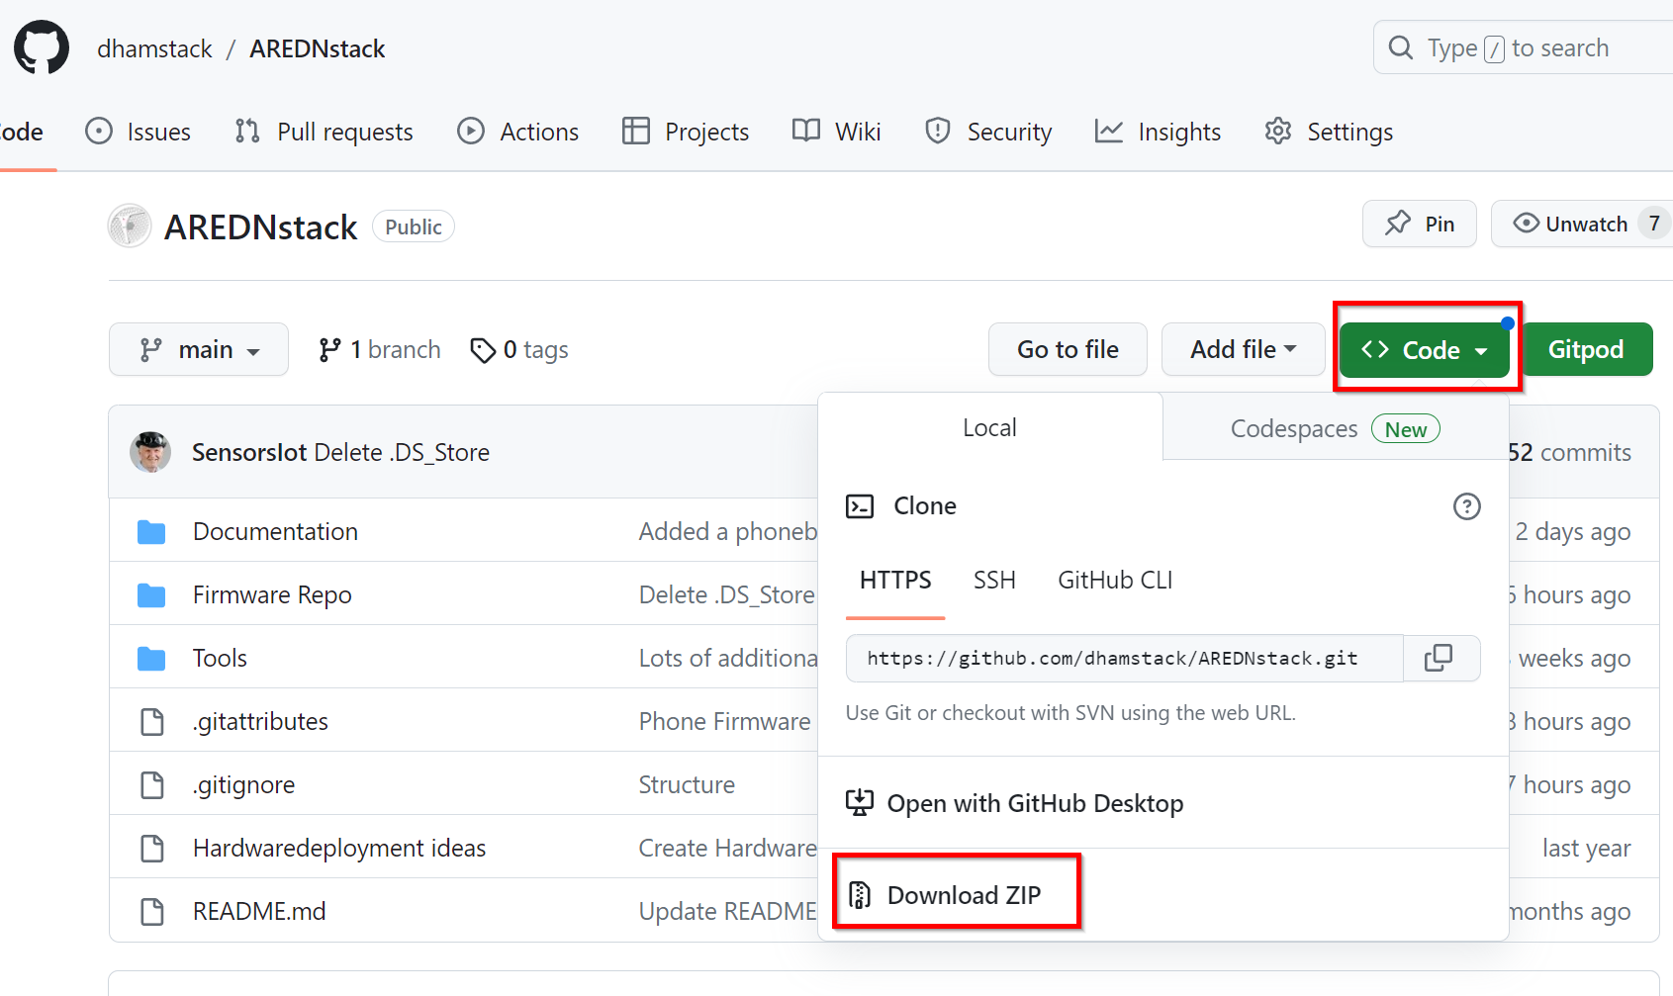
Extract the ZIP file:
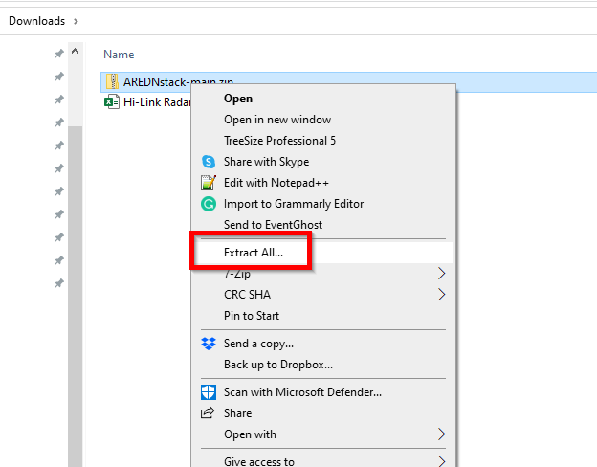
Now you should have all the needed files in your Downloads/AREDNstack-main/ folder:
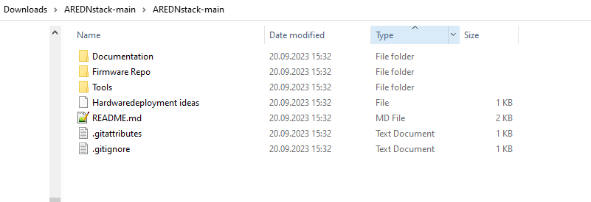
Here you find firmware for our typical phones to flash with "free" firmware (not connected to a provider).
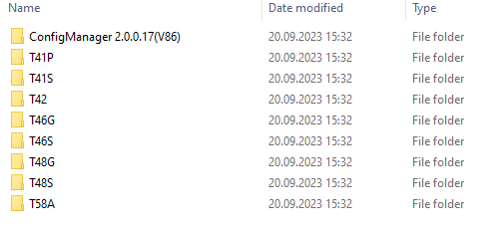

Yealink Phones

Flash the Phone
This is not always needed. Try first without this step and return if needed. Continue with “Phone Setup”.
- Download and unzip tftpd64.464.zip (the "run", not the setup version) (https://bitbucket.org/phjounin/tftpd64/downloads/ )
- Disconnect your computer from Wi-Fi and Ethernet and set a fixed IP address (e.g., 192.168.0.4)
- Start tftp64.exe
- Click the browse button to locate the TFTP root directory
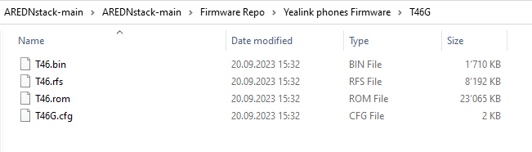
You should be able to see the files your phone will request during flashing.
- Select the local IP address from the "Server Interface" drop-down menu.
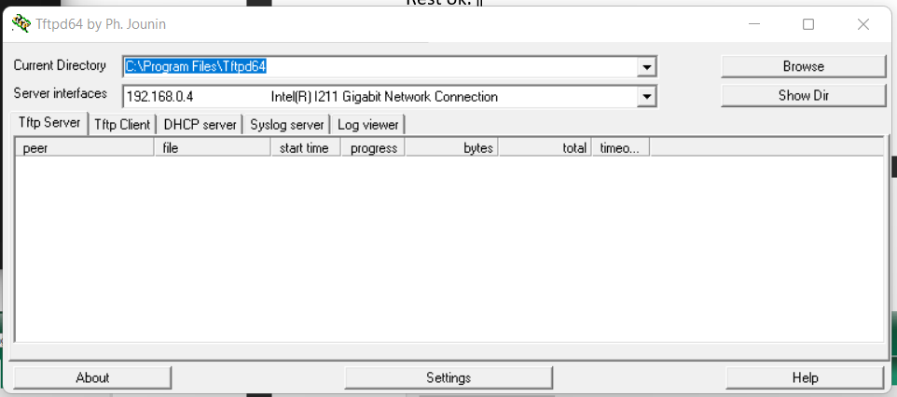
If you do not find your fixed IP, something is wrong, and you must start over.
- Connect the SIP phone to the PC with an Ethernet cable. Use the “Internet” socket on the telephone. Use the “Internet” socket on the telephone
- Power the Yealink with the speaker button pressed until you see a selection(TFTP or USB) or the below screen. Press 1 for TFTP if presented.
- Fill in the fields as shown. Make sure you use a free IP address for the telephone (e.g., 192.168.0.230 ):
IP Addr: 192.168.0.230
Netmask: 255.255.255.0
Gateway: 192.168.0.1
TFTP IP: 192.168.0.4
- Hit enter (OK) and wait. The display on the phone shows “Start Updating…”. You should see in the tftp64 window on the PC that the phone fetches files from your computer.
- As soon as all files have been read from the PC, the phone will automatically restart. However, this can take a few minutes. As soon as the phone displays a display again (e.g. “Obtaining IP address…” carry out the following step
- Hold down the OK button until the message “Reset to factory setting?” appears. Confirm this message with the »OK« key. The message “Resetting to factory setting, please wait” appears, and then the welcome screen appears.
- Remove power from the phone
- The flashing of the SIP phone is now finished, and the phone is now ready for settings for the AREDN mesh.
- Connect the phone to your hap router (port 2-4) and to power. After booting, go to the “About” menu on your phone to find the IP address.
Now, you are ready for the next step.

Phone Setup
Attention: Does not work with T42 phones. The entries must be made manually (see Checks)
With the firmware for your phone, you also find a file with the extension .cfg.
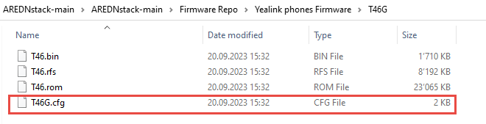
Edit this file and replace XXXXXX with the phone number you want for your phone. You can change the language by placing the # in the right place.
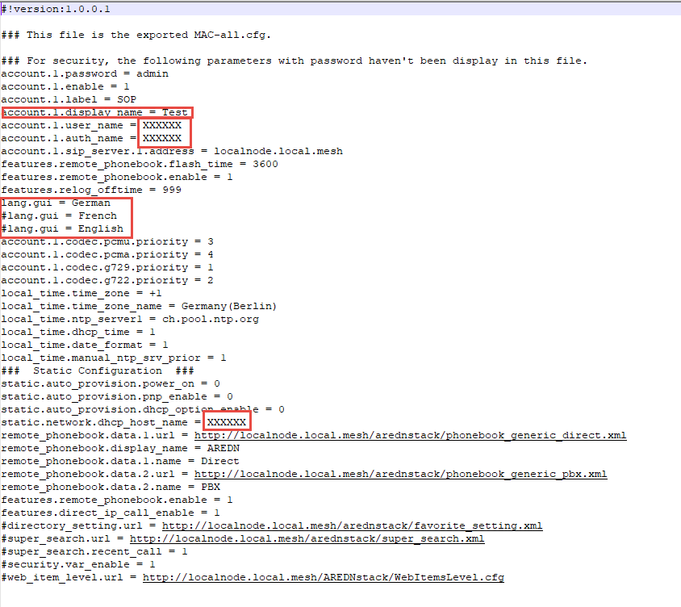
Replace the display.name if you want. Save it.
Go to a browser, type the IP address of your phone into the address, and login using admin/admin.
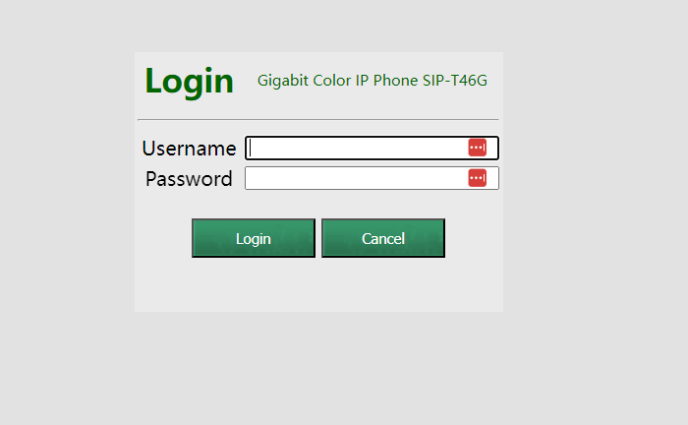
Change your password if you want.
Now go to Settings Configuration.
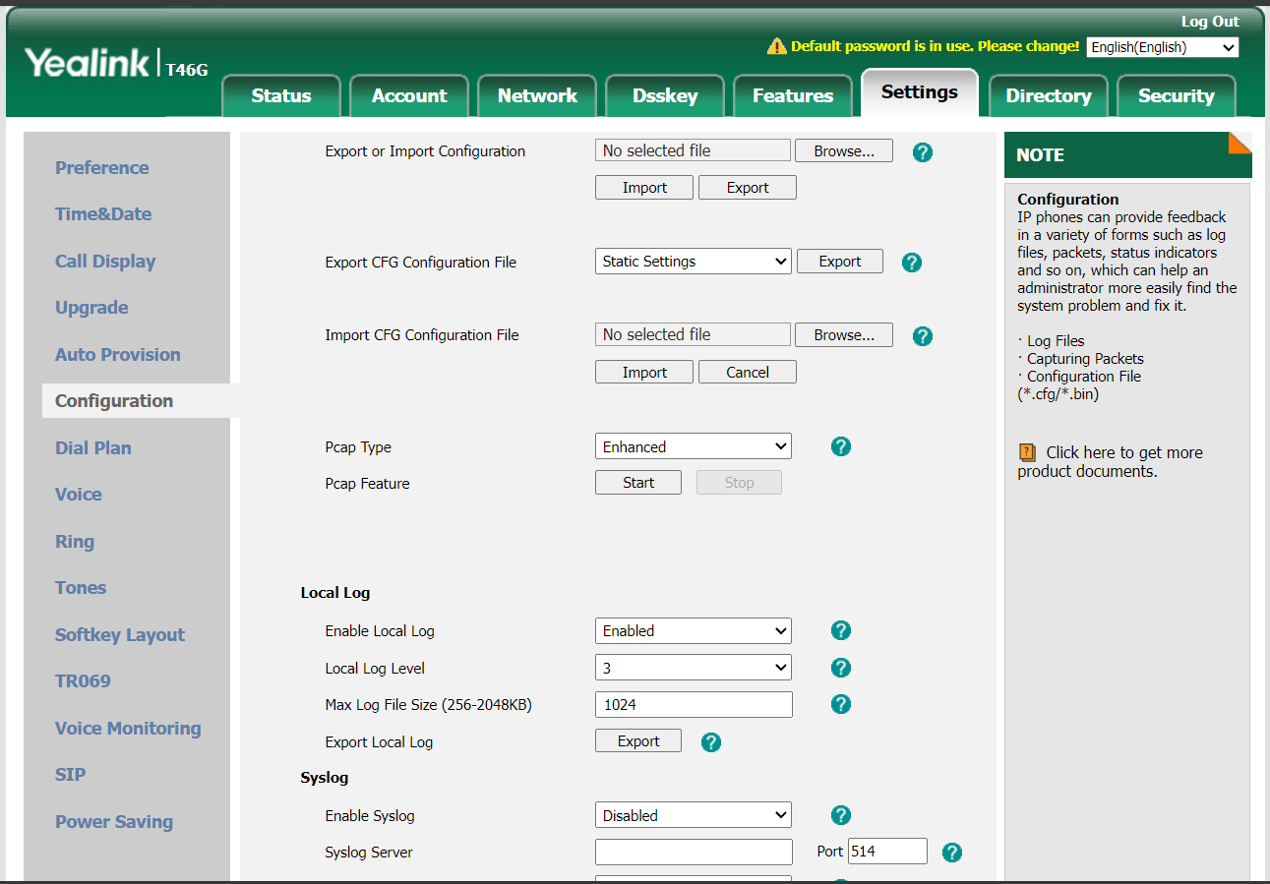
Go to "Import CFG configuration file and browse to the Txx.cfg file you edited before. Hit "Import" and wait till the phone rebooted.

Checks
Has to be entered manually for T42
SIP Server and your phone numbers have to be correct
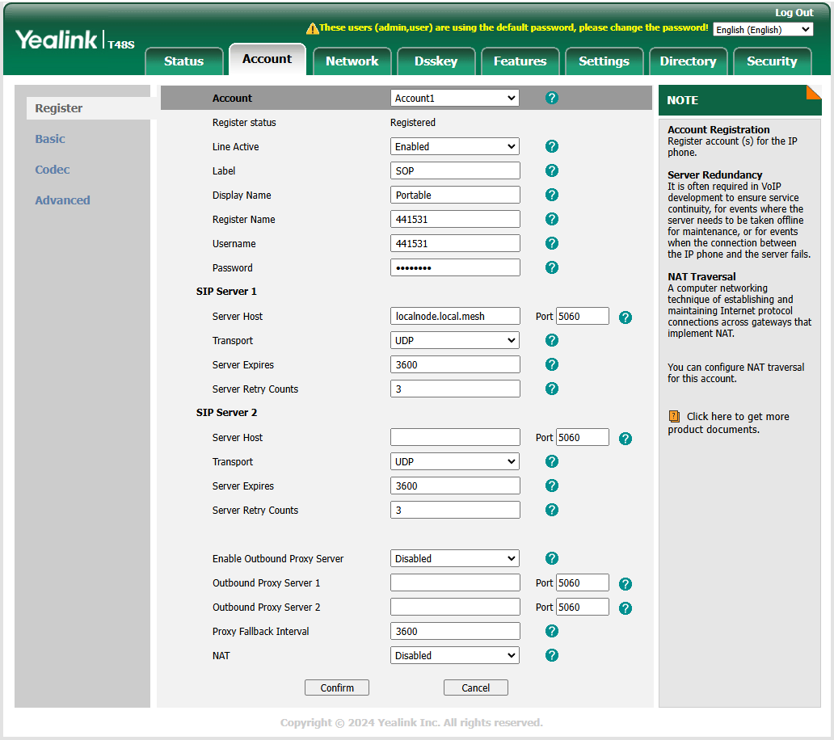
Check if your phone is enabled for IP telephony:
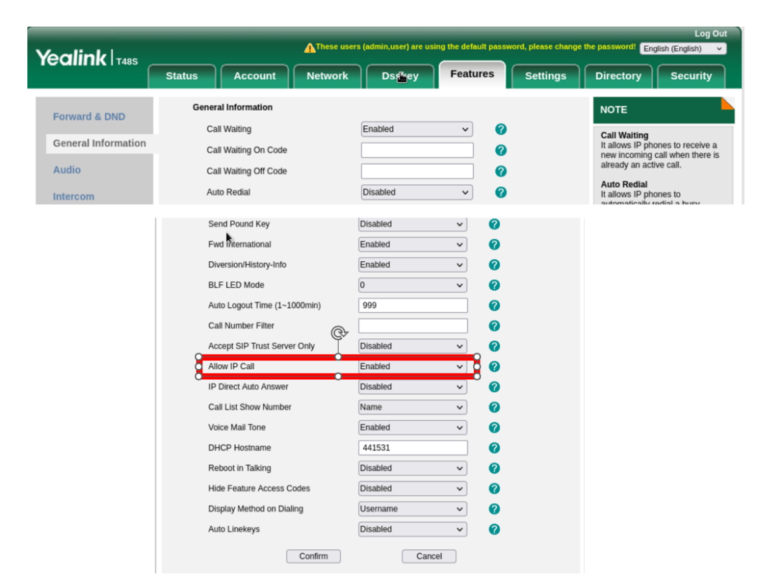
Go to Directory Remote Phone Book and check if the remote phone book screen looks like that:
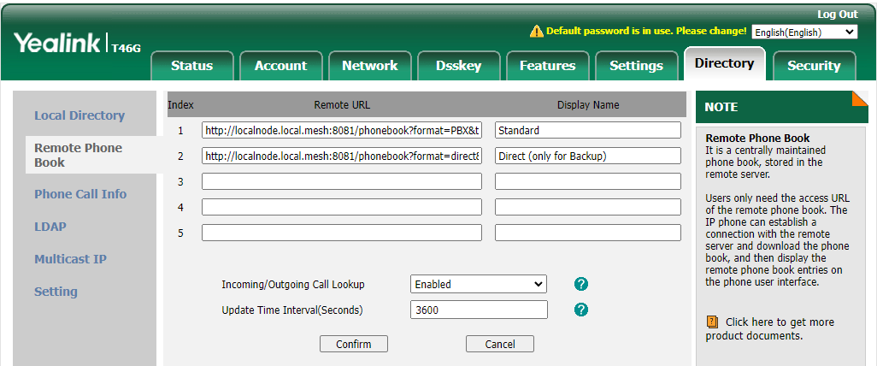
The two phonebooks for copy-paste (only if they are not here):
Standard phone book:
http://localnode.local.mesh:8081/phonebook?format=PBX&target=generic&ia=true
This file only stores the telephone number. The PBX knows this number anyway, and the SIP server in the phonebook program automatically creates the mesh address for direct calling.
Backup phonebook (with full mesh address):
If you want to store the full mesh address as a backup on your phone, you can add the second line. It is not needed.
http://localnode.local.mesh:8081/phonebook?format=direct&target=generic&ia=true
Go to Directory Check or adjust fields. They should look like that:
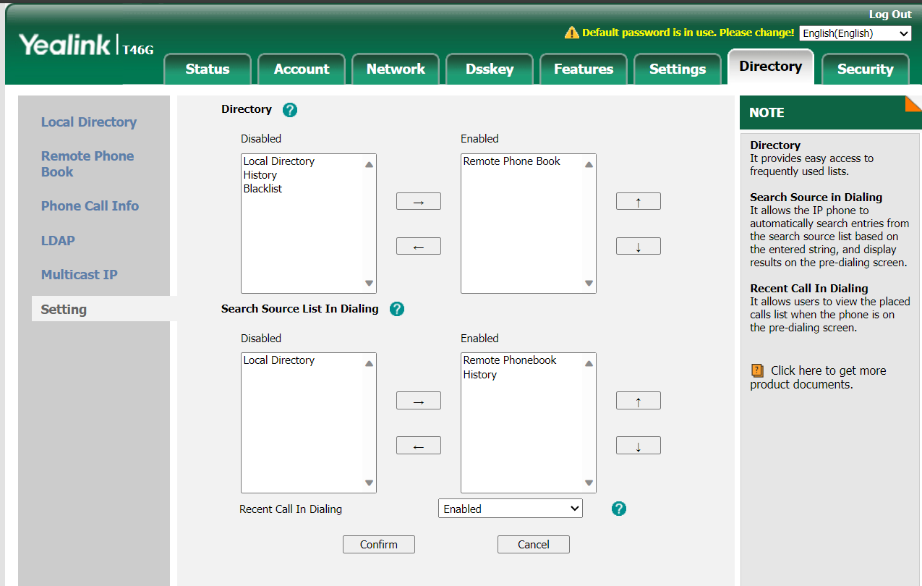
Press “Confirm”
Now, you should see a small phone in your phone's display that shows it is ready for the AREDN network. You should also see a "direct" and "PBX" folder if you press the "Directory" button on your phone.
If your Mikrotik router already works with AREDN, you can skip the next step and install the phonebook. If not, continue with the next chapter.

Flash Mikrotik devices

Preparations
The small Mikrotik hap ac-lite/ac3 box or square Access PointSXTsq (AP) will hereafter be referred to as "target devices." Green are the notes for the AP.
Download the “kernel” and “sysupdate” files for your device. Every letter in the name counts!
https://downloads.arednmesh.org/afs/www/
Rename the kernel bin file file to rb.elf.
Download the Tiny PXE Server (http://erwan.labalec.fr/tinypxeserver/pxesrv.zip ) and unpack it to a convenient directory.
Go to the Tiny PXE Server directory:
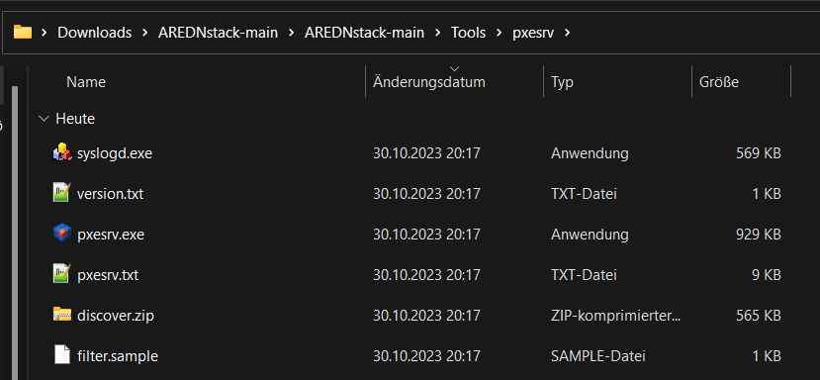
And copy the rb.elf file from before to the «Files» folder of the PXE server (overwrite if necessary).
Connect your target device to a switch as shown below (connect the LAN cable to the “internet” port of the hap router):
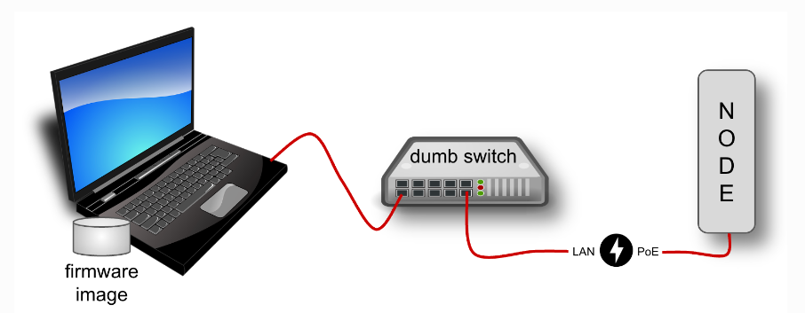
Deactivate Wi-Fi on the PC and supply power to the dumb switch.

Change PC to a fixed IP address
Type
ncpa.cpl

into Windows search
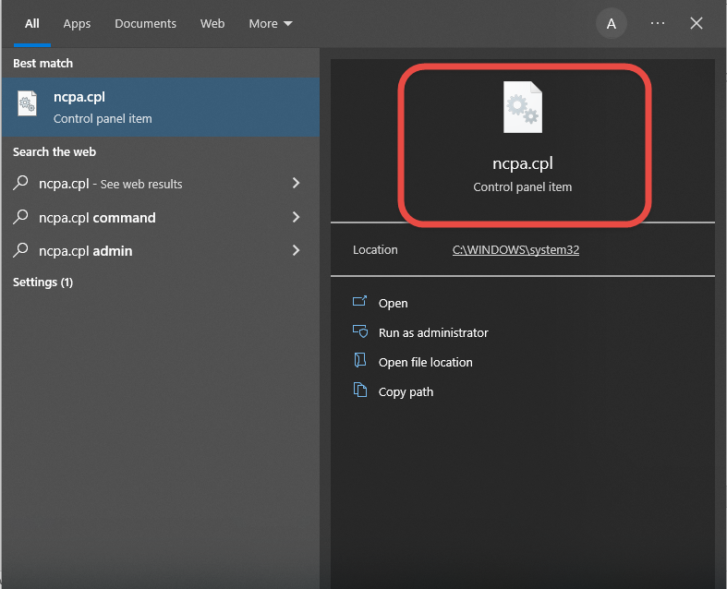
Select "Ethernet"
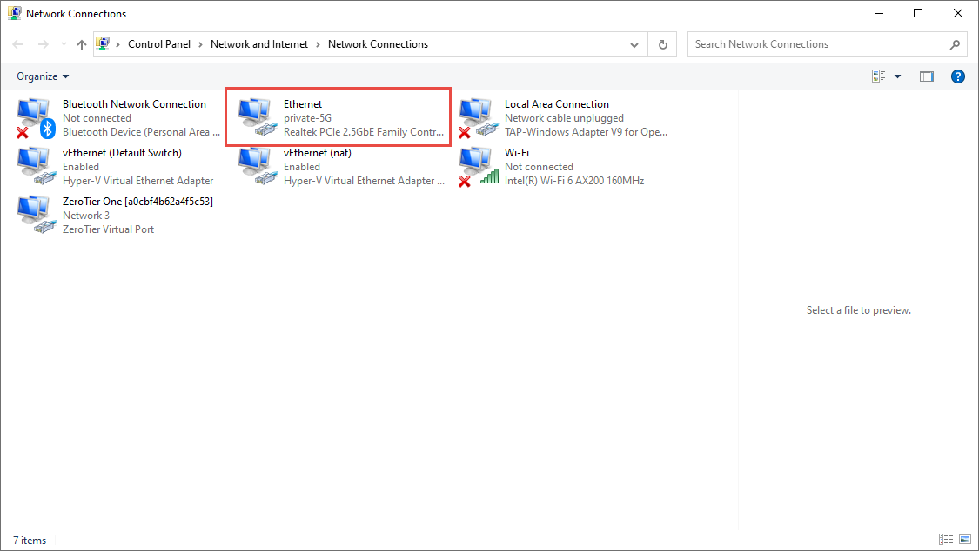
Select «Properties»:
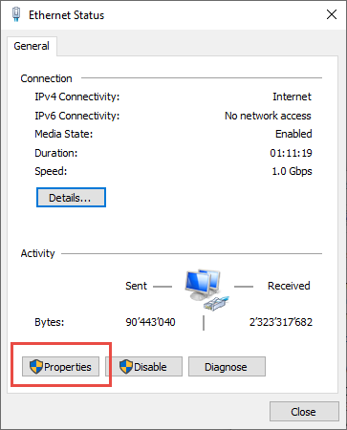
Select IPV4:
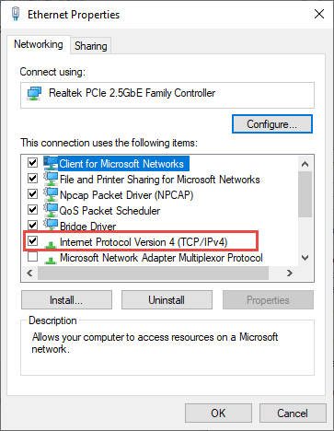
Input IP address 192.168.1.50:
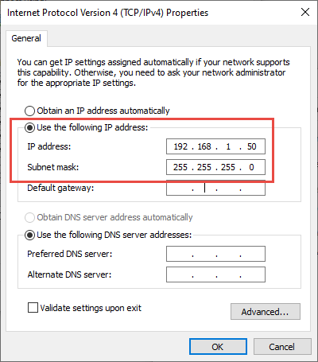
Press OK and Close

Flash rb.elf to target device
Power the hap devices with a power supply, not with PoE.
Check if the ethernet cable is connected to port 1 of the hap router (labeled with Internet), supply the router with power and wait until the top red LED is off and the green LED above with the number 1 flickers. Possibly Windows detects a new network. Then a larger blue window will appear on the right side of the screen, mentioning the new network. Confirm with OK. The whole thing takes about 3 minutes.
Do the same with the AP. Use the PoE injector (Y-cable) or a passive PoE switch for the power supply. The power supply unit of the router also works here (both are 24V).
Start Tiny PXE Server (double click on the pxesrv.exe file in the «pxesrv» directory). You might get this warning:
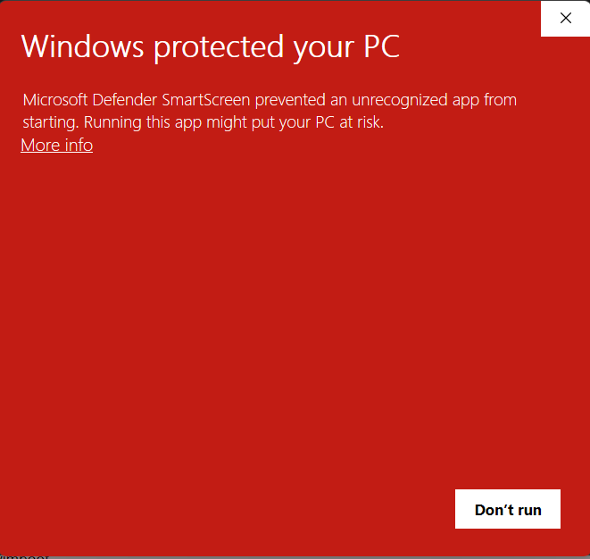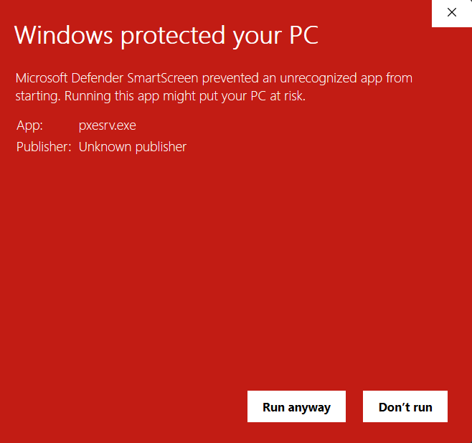
Press «More info» and let the program run.
Now pull the power of the target device.
In the Tiny PXE Server window, select the IP address entered on the Ethernet adapter from the drop-down box (192.168.1.50). If this IP address cannot be selected, close the Tiny PXE Server and start it again. If it still doesn't work, check the IP4 adapter settings and start again.
Find and select rb.elf in the «Boot File» section. This file can be found in the «…\pxesrv\files» folder.
Uncheck «Filename if user class...». No additional settings are necessary.
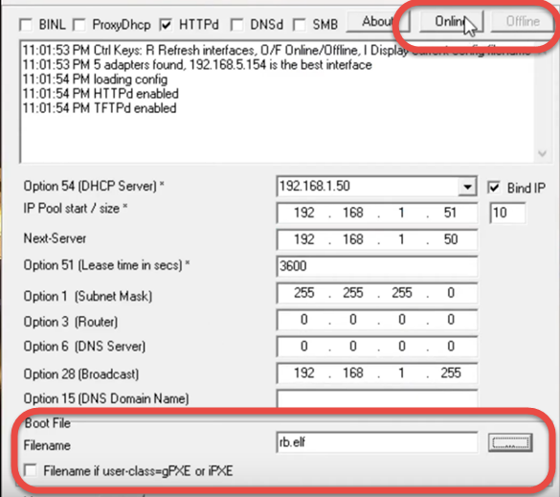
Now switch the Tiny PXE Server to «Online» in the upper right corner.
Then press the reset button in the target device with a pointed object (e.g., paper clip or toothpick) and then plug in the power cable to the target device. The USR LED will be on, flashing, and off (5 seconds each). Check the log window. Immediately after the bottom line says "Do ReadFile:rb.elf ………" release the reset button and switch the Tiny PXE Server to "Offline." This procedure takes about 20 seconds. The target device now boots with the AREDN firmware.
Don't keep the reset button pressed for too long, or you'll have to start over!
Keep the device powered. Otherwise, you have to start over!
If new messages (new requests) keep appearing in the window, you must use a different PC. Preferably one with little software installed.
After a few minutes, the process should be finished.
Plug the Ethernet cable into port 2 on your router
With the AP, the Ethernet cable remains in the only socket. The rest is the same

Flash AREDN Firmware
Now open a browser and enter 192.168.1.1. The picture should look something like this.
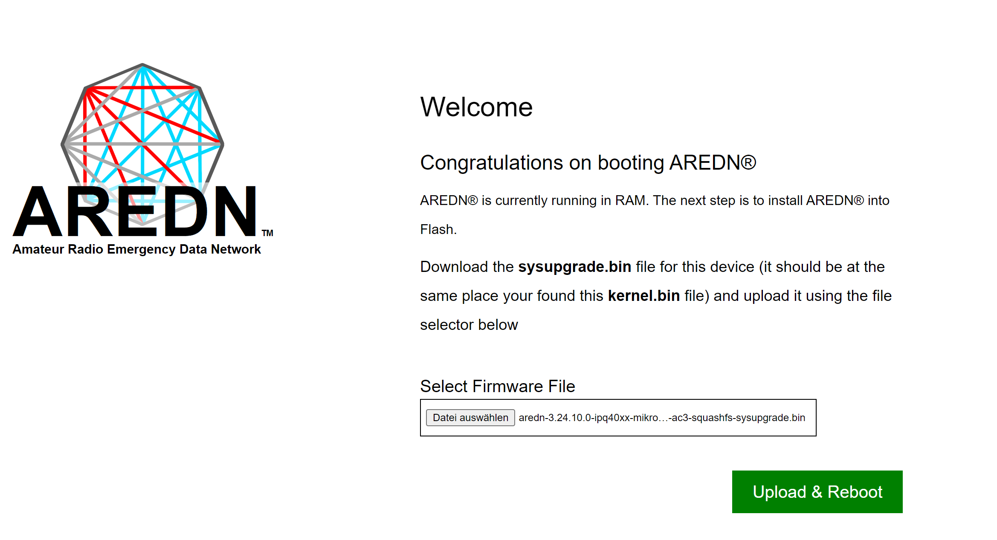
If not, back to start.
Now you can select the sysupgrade file for your router and hit “Upload”. Wait till you get an answer on http://192.168.1.1
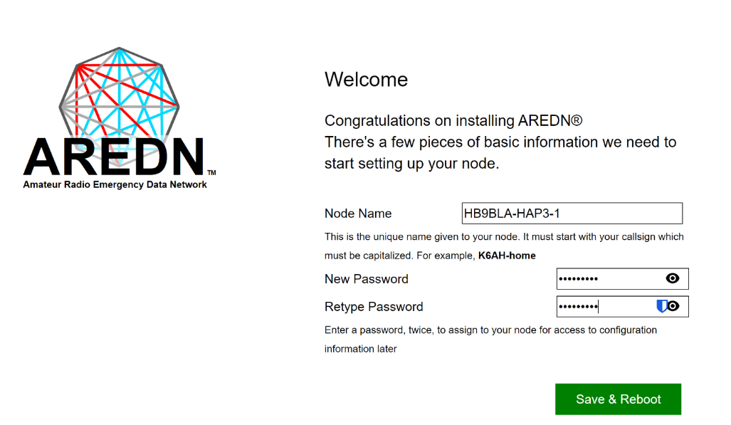
Enter the node name beginning with your call sign.

Configure AREDN
Change your PC to DHCP. Open the browser and enter the following line
http://localnode.local.mesh
If there is no answer, the process is not yet complete. Try again and again. If you still can't connect after 15 minutes, go back and start over.
The new screen should show up where you can login to administer the node.
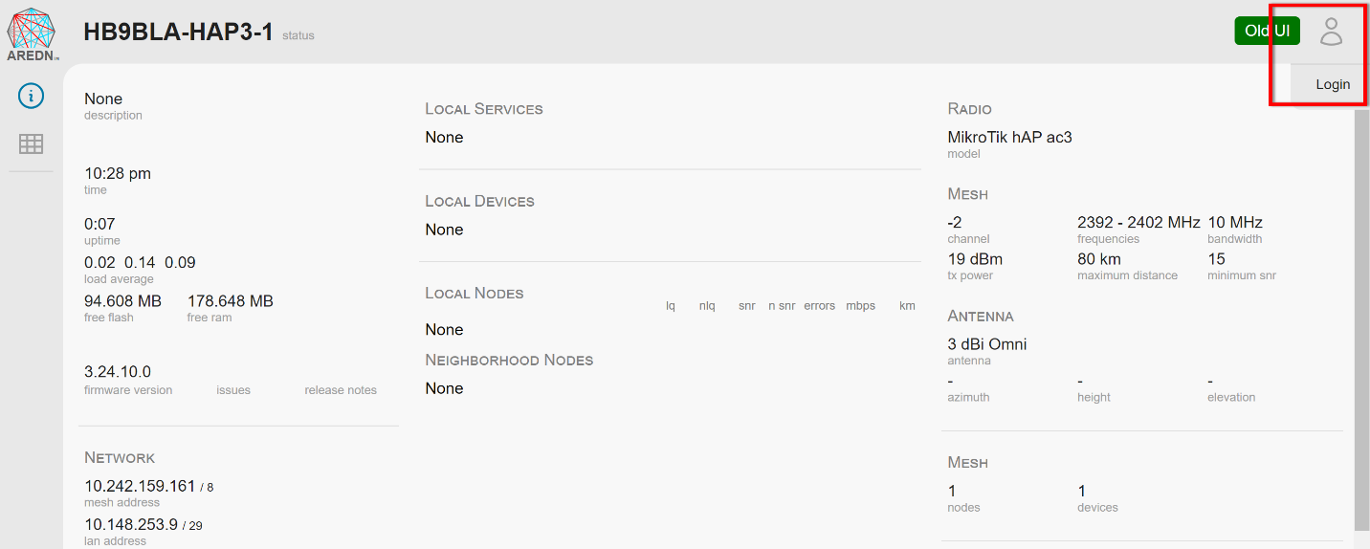
You see if you are in administration node when the UI looks like that:
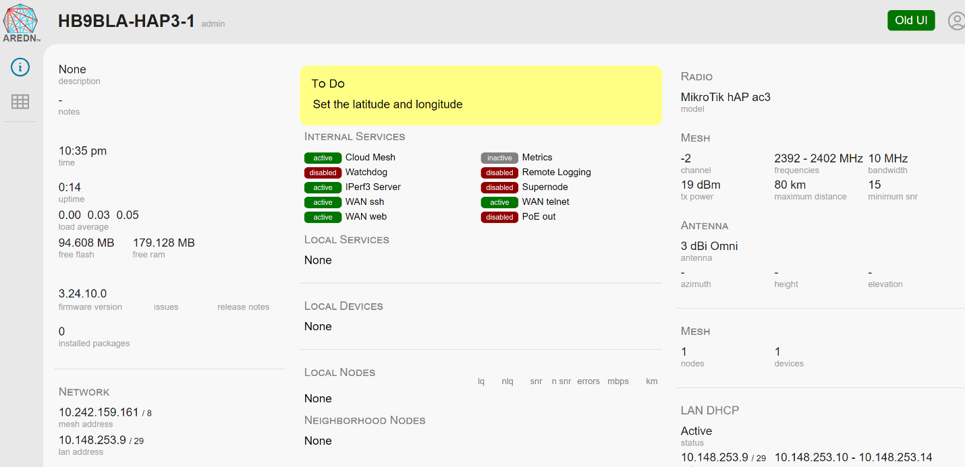
Changes are made everywhere on the screen when you see a grey shadow.
After changes, you have to commit them, and sometimes you are asked to reboot. There is no «reboot» button anymore.

My recommended settings for the hap routers (for the moment)
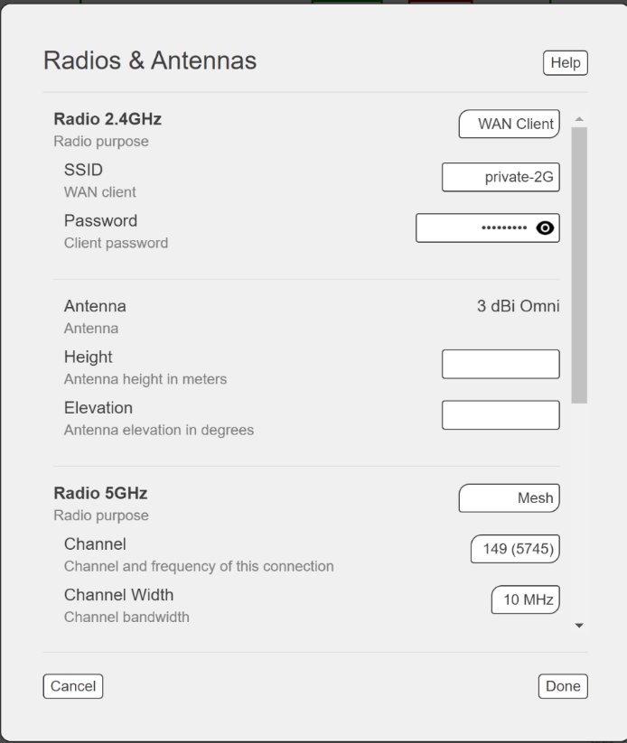
I connect my hap routers to Wi-Fi and create a mesh on 5GHz to test with other AREDN nodes. If you connect the hap via cable to the internet, you can switch the 2.4GHz radio to “off”.

Make your telephone visible to the network
Telephones have to be visible to others The is why we have to reserve the address. This is done in the “LAN DHCP” area on the right. If you clock it you get to this screen:
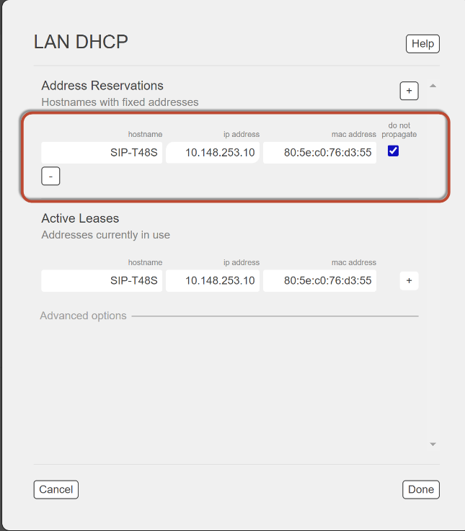
If you connect your Yealink phone, it should already be visible, and you just have to press the “+” button. Change its name to one of your unique phone numbers. You get the telephone numbers from HB9JAT, HB9BND, or HB9BLA. MAC address is found on the telephone under «information» (if needed).
Remove the tick at “do not propagate” to make it visible in the net.
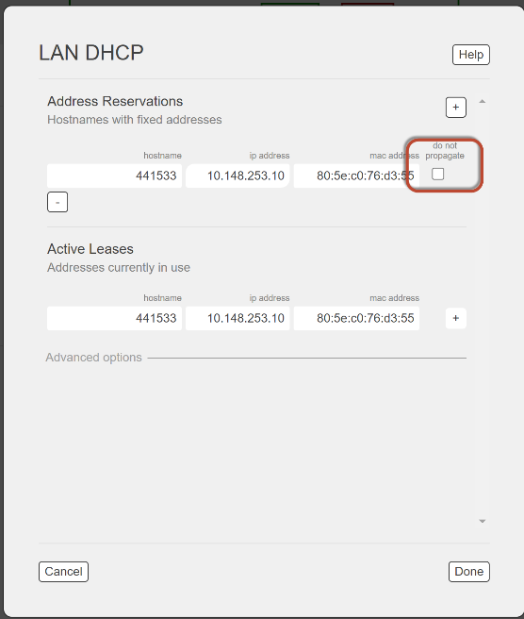
Now it is time to go to the network overview:
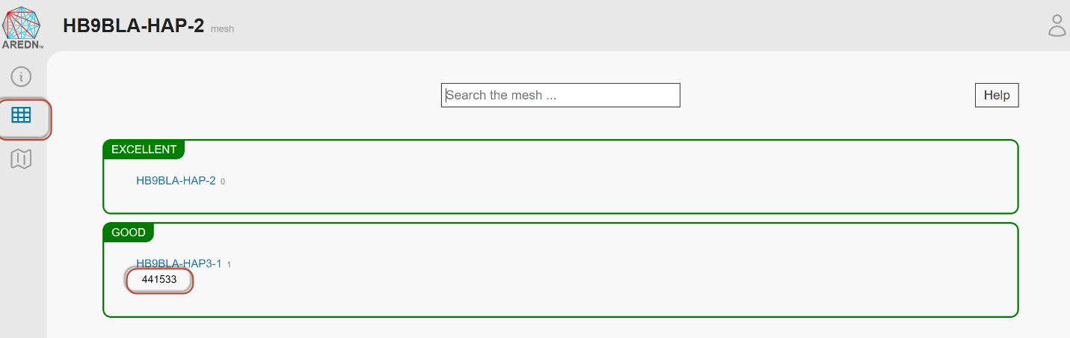
The phone should be visible under your router name.

Set up a tunnel to the AREDN network
(only necessary if you connect via an Internet tunnel)
This chapter only applies to the hap routers.
Connect port 1 (Internet) to the Internet or connect via the network as shown before in my recommended settings.
From now on, you can access the router either if you connect a cable from your PC to ports 2-4 or via Wi-Fi.
The router should provide a network.
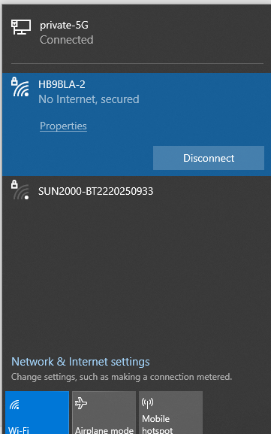
There are two different tunnels available. The owner of the tunnel server decides which one you have to use. Wireguard tunnels are the future.
The tunnel owner will send you a file with the needed info. For legacy tunnels, make sure your node name matches the one given to you by the owner. Otherwise it will not work.
Server: his server address
PwD: The password he assigned to your tunnel
Network: The address of your tunnel

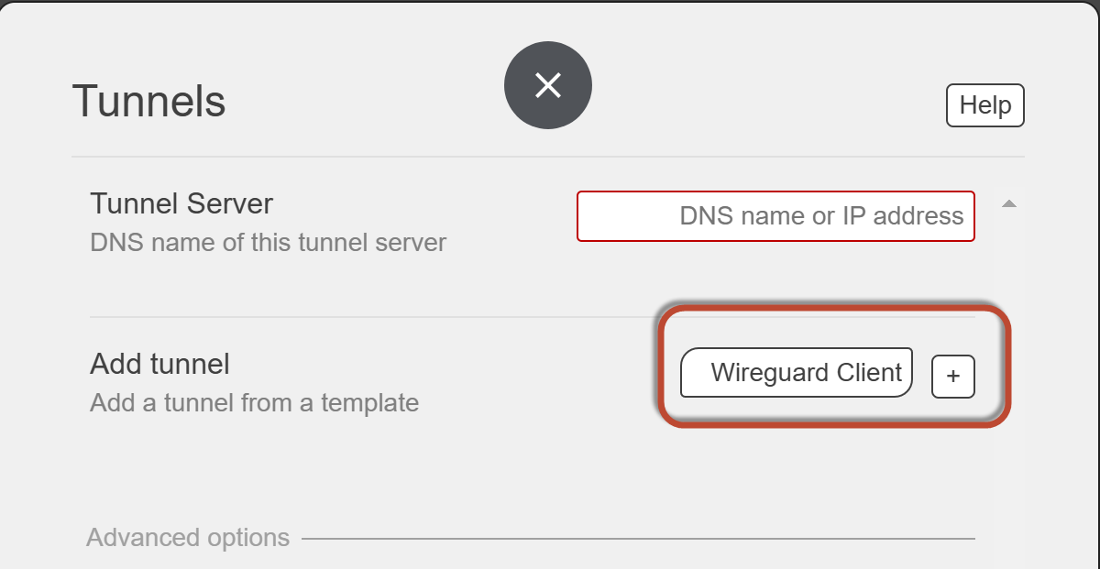
The field “Tunnel server” is left blank for clients. Chose Wireguard or Legacy client, press the plus sign, and fill in the information you got from the tunnel owner.
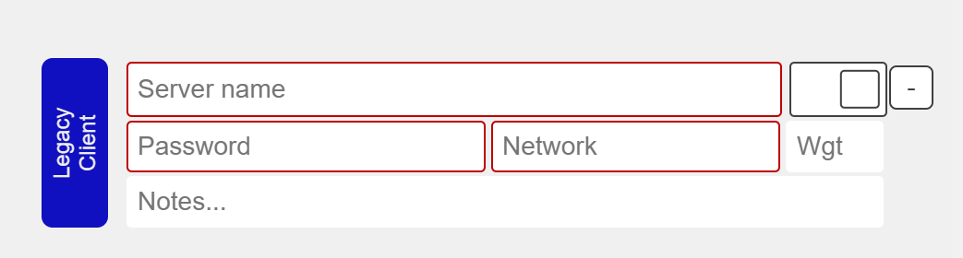
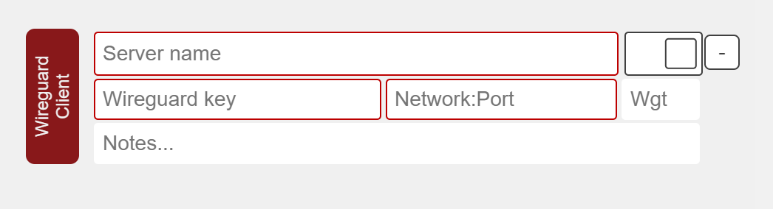
After you commit the changes, you should be connected (green) and your network should start to populate. You are now connected to the AREDN network. Go to «Node-Status» / «Mesh Status» and enjoy the success.
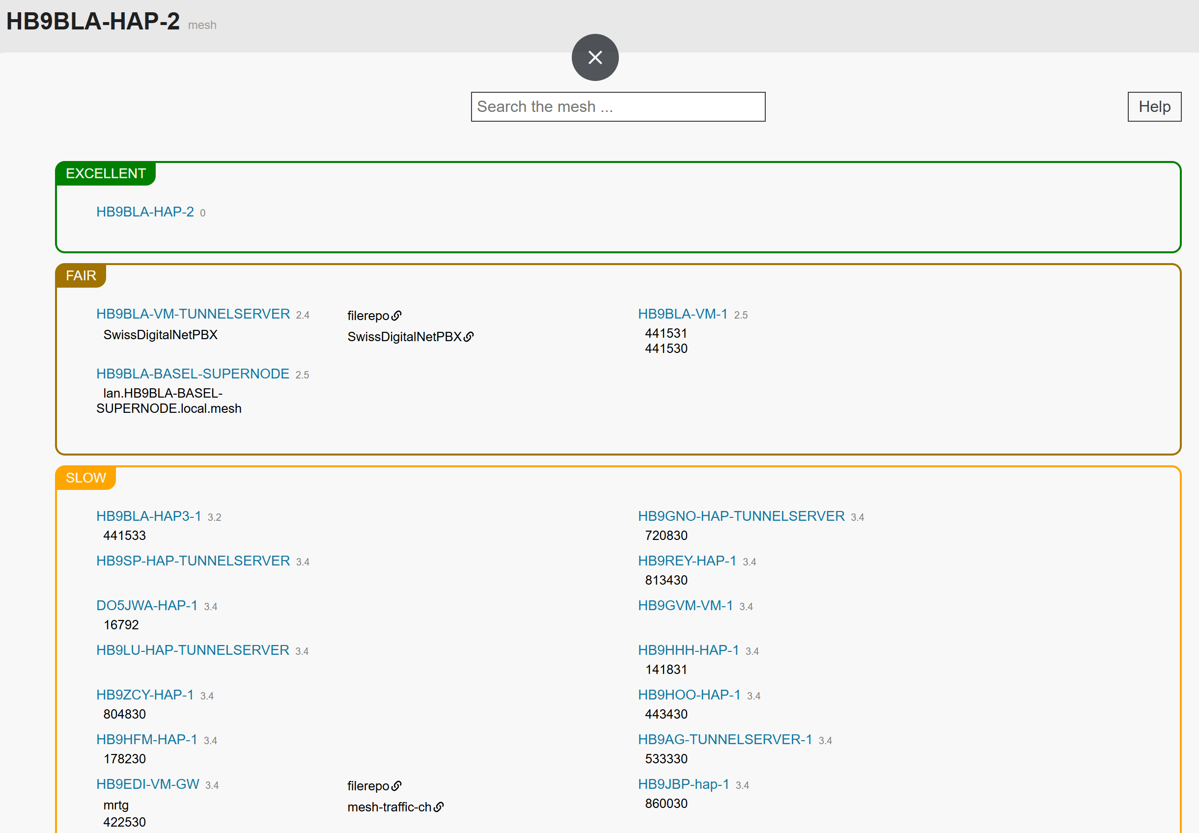

Install the Phonebook
This project aims to create a common Global AREDN telephone network. Local telephone books are distributed to all participating AREDN phones connected to the SwissDigitalNetwork or, via Supernodes, worldwide. By storing the latest version on each router, we can ensure that, during an emergency, we have no single point of failure. Each phone can call all reachable phones without a (central) PBX.

Principle of operation
You can skip this chapter and go to "Installation" if you are not interested in how the telephone book works.
AREDN is a mesh network, and we do not want to create a single point of failure. This is why the telephones get their phonebook files from the hap router they are connected to. So, a phone gets its phonebook as long as its router works.
We use direct calling instead of a PBX to avoid a single point of failure for communication, reduce the latency time, and reduce the overload of single mesh segments. The address used for this case is an FQDN like 178230@178230.local.mesh. If you want or need to operate a PBX, the address is just a phone number like 178230. In Switzerland, we use the city's zip code of the HAM plus a two-digit number in the range of 30-70. Lower numbers are reserved for official use.
The "Official" Swiss AREDN phonebook (SOP) is on Google: https://docs.google.com/spreadsheets/d/1g33BHSXMC8T4Cmfz_Zq-XxtPP17dtEBexF2i4KKe_Mc/edit?usp=sharing. You can create a comment to add or change something or notify one of the administrators to do it for you.
Other countries will have their own telephone book (one per international area code). The maximum length of a local phone number is 7.
xxx-yyyyyyy
xxx: 3-digit area code
yyyyyyy: 7-digit local number (in Switzerland, currently only 6 are used)
Examples:
A global number in Switzerland starts with 041 (e.g. 041441530). For your comfort, you only have to dial the short number (in Switzerland, 441530). The SIP server in the phonebook program automatically adds 041 (it is defined in the config file).
Other nations use their international area code. It must have three digits. So, the US has 001 and Lichtenstein 423.
Currently, we support Yealink telephones. Cisco phones should also work.
At power-up and every hour, the telephones used for AREDN automatically load phonebooks from the connected router. The file format used for that process is XML.
How is the information transferred from the Google Sheets to your hap router? The first step is to copy the .csv version of the sheet from Google to two web servers (one acts as a backup) in the AREDN mesh. If Google is down, we could still edit this .csv file manually. This transfer is done every hour. You find more info in attachement.

Installation
Go to the releases page and open “Assets”:
https://github.com/arednch/packages/releases

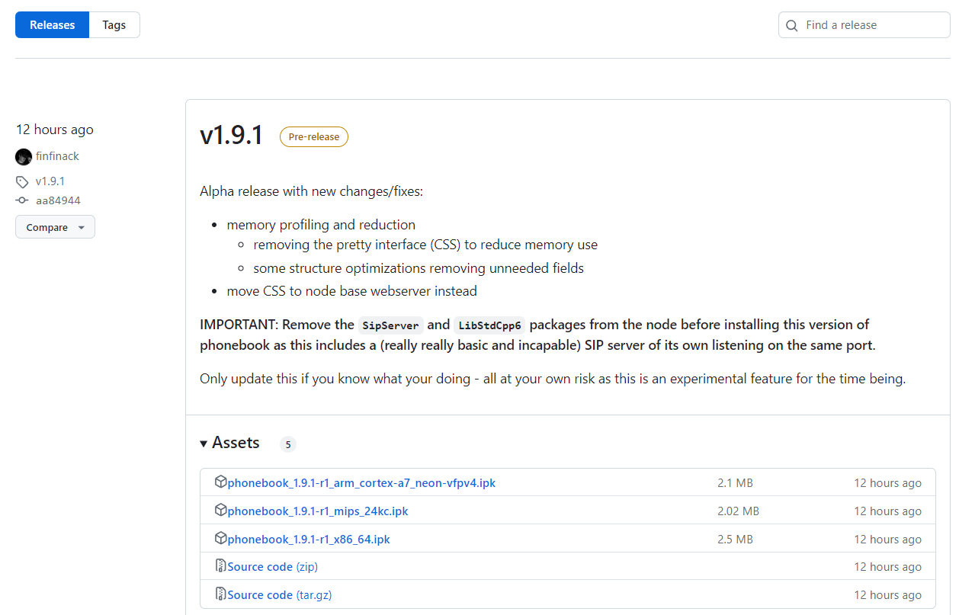
Download the respective ipk file (mips-24kc for the small hap lite and arm-cortex for the hap3). The ipk file includes the phonebook, the SIP server, and all libraries.
Go to “installed packages” on the left:
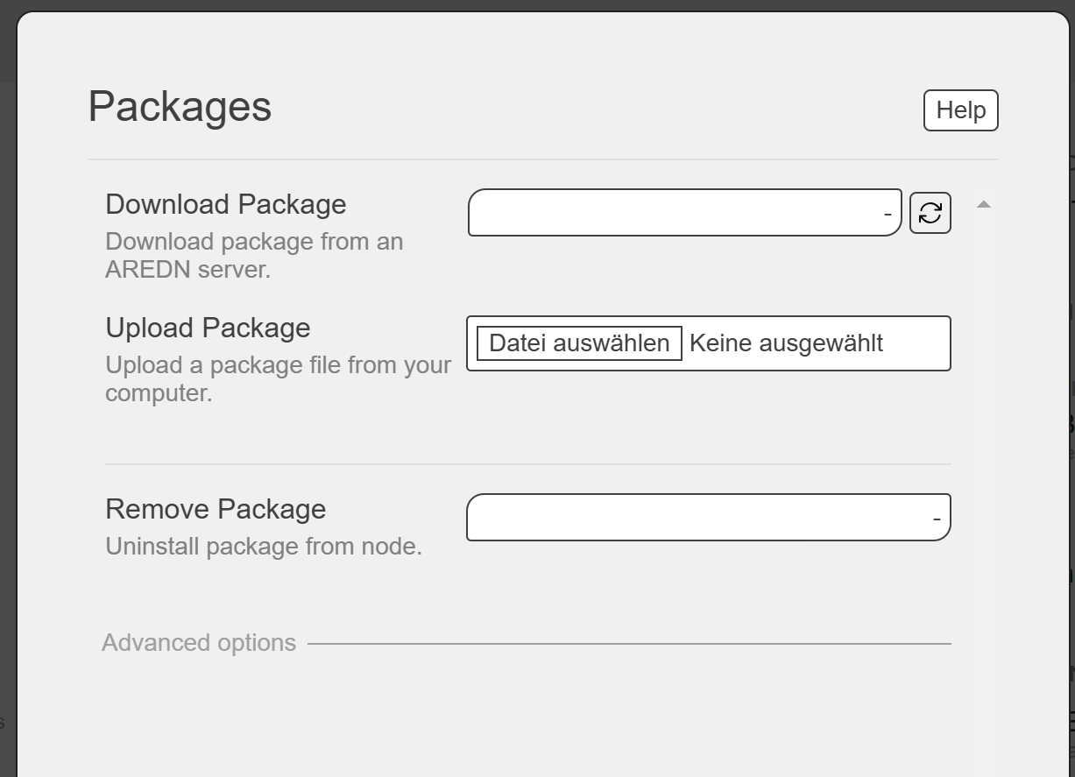
Chose the correct “phonebook” file and “upload it. This starts its installation.
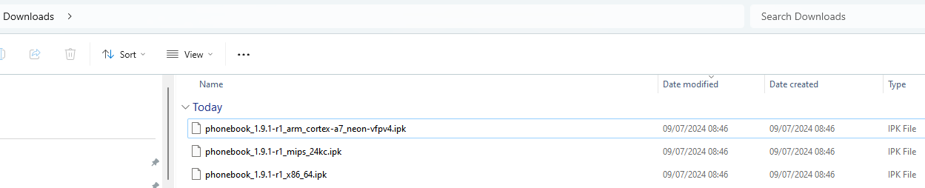
Now, you can connect your router to your AREDN network. After rebooting, the attached phone should connect to the SIP server, and you should be able to download the phonebook with all numbers.

Troubleshooting:

Is the phonebook downloaded?
localnode.local.mesh:8081/phonebook?format=direct&target=generic&ia=true
should show you the actual phonebook
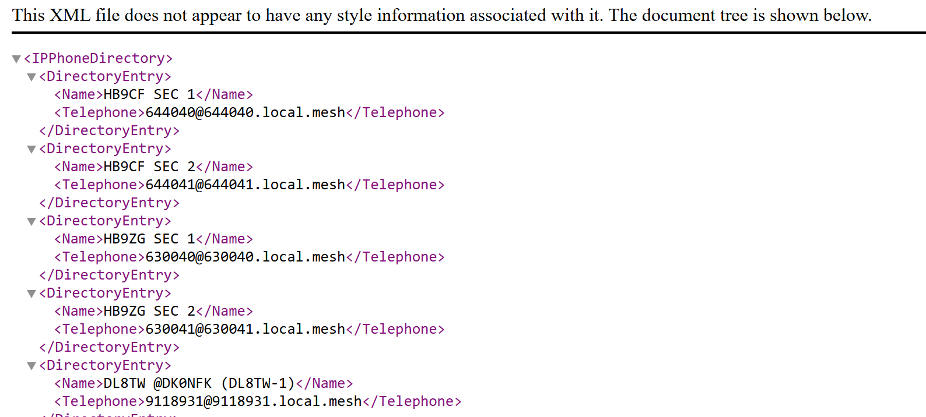
if not, type:
localnode.local.mesh:8081/reload
should load the actual telephone book from the AREDN server
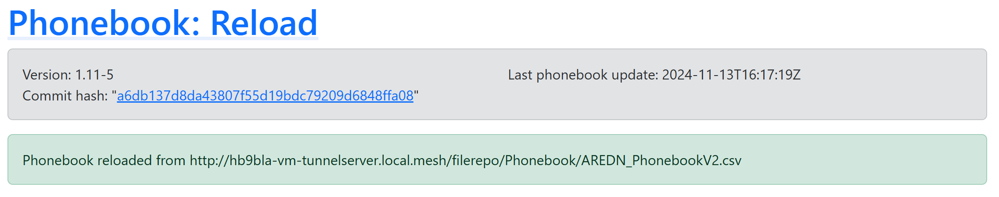

Config file (only for experts)
You can influence the behaviour of your phonebook software by changing parameters with the command
vi /etc/phonebook.conf
Important are these two parts:
formats: Comma separated list of formats to export.
Default:
"formats": [
"direct",
"pbx"
],
- Supported: "pbx,direct,combined"
targets: Comma-separated list of targets to export.
Default:
"targets": [
"generic"
],
- Supported: generic,yealink,cisco,snom

Using a PBX in parallel
If you want to use a PBX, you must add a second account with the respective information given to you by the PBX operator.

Install phonebook on a Raspberry Pi (needed after 3.25.0)

Hardware
With each release, the memory of the HAP Lite routers is more used. From AREDN 3.25.0 onwards, the phonebook no longer has sufficient space. Therefore, we need a solution.
Martin created a version of the phonebook for the Raspberry Pi. So we can use any Raspberry to host it. My preferred solution is a Pi Zero because it is quite small. But because it has no Ethernet connector, we either have to connect it via Wi-Fi to the HAP lite, or we use one of these small USB-RJ45 cables:
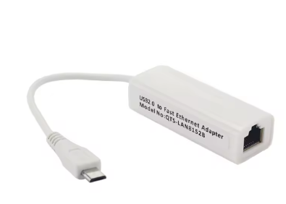
Or you use an old Pi3.

Software installation
Next, we need to create an SD card using Pi Imager. I prepared a version with everything installed.
You can download it from here:
https://drive.google.com/file/d/13LI0mwhcDH-T6AzRpbhtvQxxWXn5o5lF/view?usp=sharing
The username is Pi, and the password is “raspberry”. It is a 32bit Raspberry OS and should run on all Pis
Select the file in the Pi imager (Use custom)
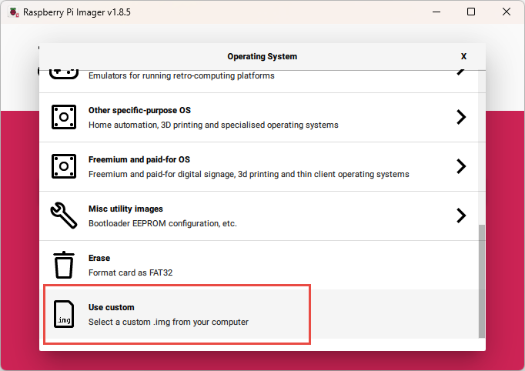
When finished, insert the ready-made SD card into the Pi, power it up, and connect it to ports 2 or 3 of the HAT Lite. Then, power up the Pi.
To proceed, we go to the home screen of your HAP router:
http://localnode.local.mesh

On the screen, log in.
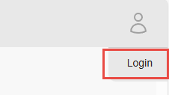
Now, you should see your Raspberry Pi. Its name is PhoneBookServer:
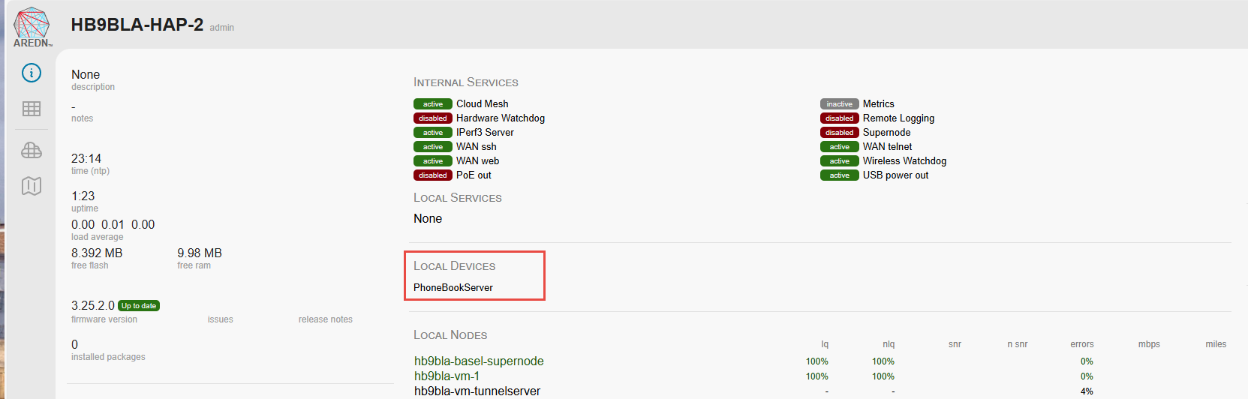
If you click into this area:
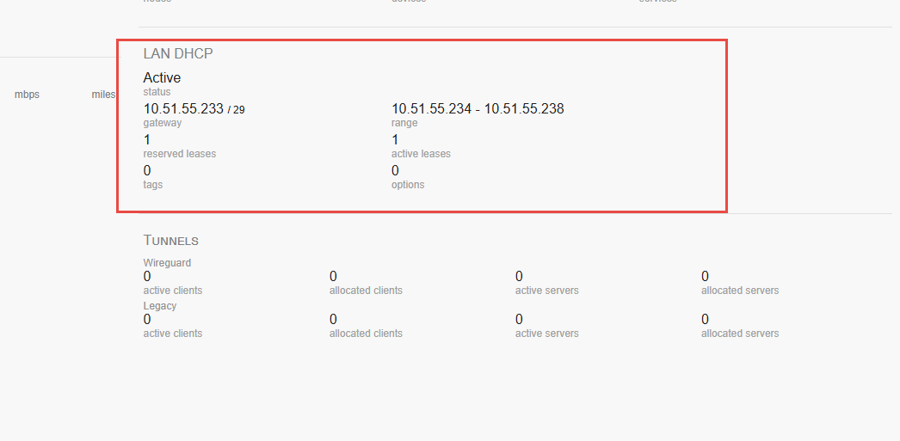
You should see its address.
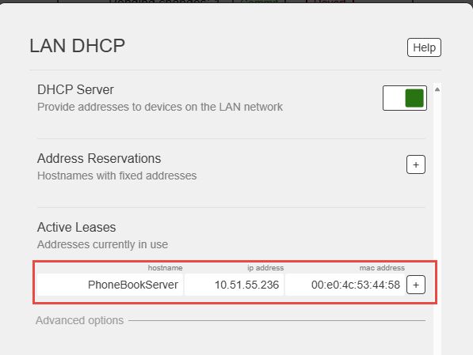
Press the + sign:
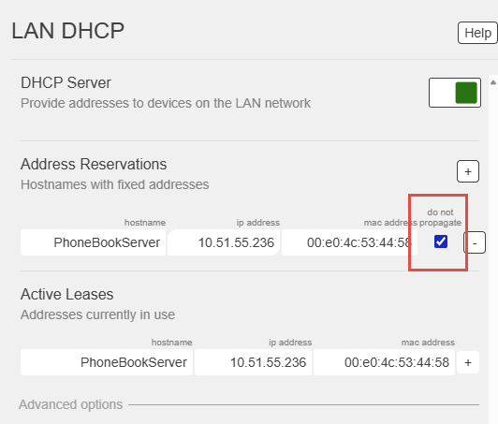
And tick the “do not propagate”. Like that, nobody will see your phone server outside of your HAP router.
If your PC is directly connected to your HAP router, you can type the following address in a different window on your browser
http://phonebookserver:8081/reload

Otherwise, use this line (IP address in our case is 10.51.55.236):
http://<node IP address>:8081/reload

Now you can check if your Pi downloaded the phonebook:
http://phonebookserver:8081/phonebook?format=direct&target=generic&ia=true
or
http://phonebookserver.local.mesh:8081/phonebook?format=direct&target=generic&ia=true

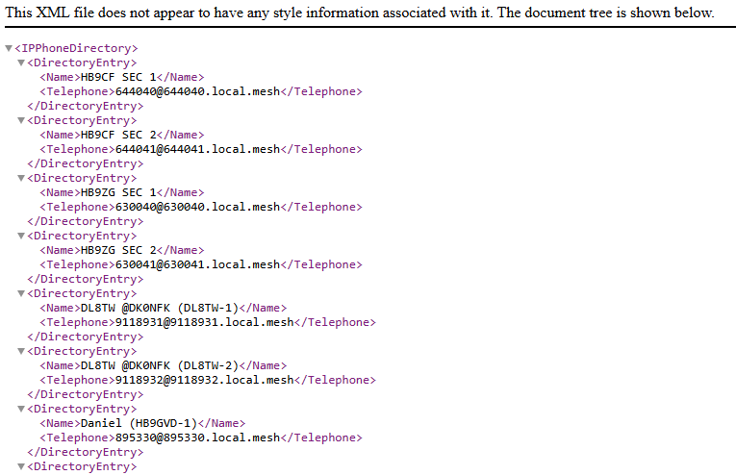

Adjustments on the phone
The only thing you have to adjust is to replace “localhost” with “phonebookserver” in these two places:
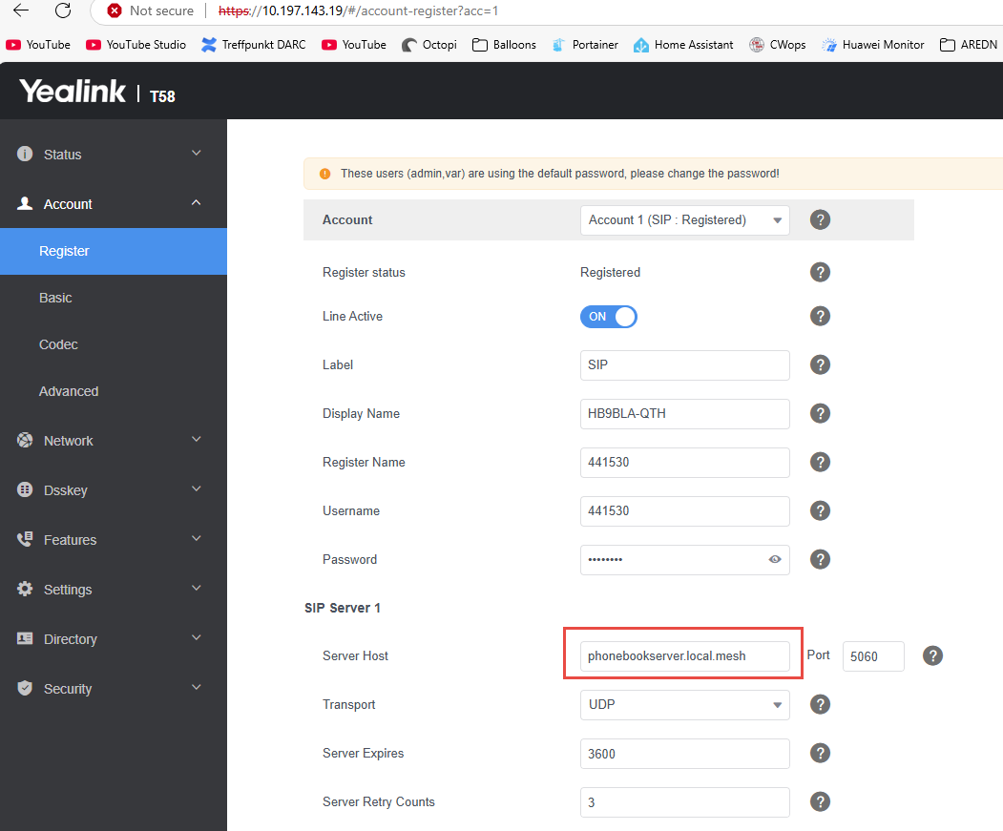
And:
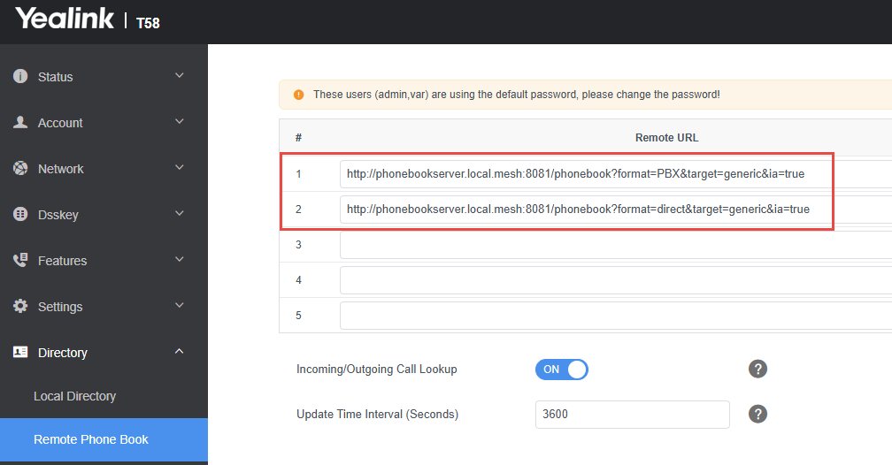
Now you can test if your phone registers and if you can refresh the phonebook. If so, you are done.

Installation of the package (for “professionals”)
Get the package from:
XXX???
For the Raspberry Pi 1 and Pi Zero, or if you want to use a 32-bit Raspberry OS, you have to use:
phonebook_armv6.deb
otherwise, this one:
phonebook_arm64.deb

You can install it with:
sudo dpkg -i phonebook_armv6.deb
or
sudo dpkg -i phonebook_arm64.deb

Uninstall for both:
dpkg -r phonebook

Now the phonebook should start at boot.

This is the end of the manual. The rest is for Administrators
------------------------------------------------------------------------------------------------------------------------------------------

Attachments
These steps are executed on the server with the file repo.

Google Sheets replication
Create a file on the “phonebook repo” server (in my case the tunnel server):
vi /etc/cron.hourly/load_phonebook_from_google
and insert:
#!/bin/sh
curl -L “https://docs.google.com/spreadsheets/d/e/2PACX-1vTZw1cwlV6pdFETvC-JnI0gPwKRwR0rBUc2XqX9V3LV1NfrB0zvhhWKmrYVS1eippbs91lMLfkeXj6-/pub?gid=0&single=true&output=csv” -o /www/filerepo/Phonebook/AREDN_PhonebookV2.csv
curl -L "https://docs.google.com/spreadsheets/d/e/2PACX-1vTZw1cwlV6pdFETvC-JnI0gPwKRwR0rBUc2XqX9V3LV1NfrB0zvhhWKmrYVS1eippbs91lMLfkeXj6-/pub?gid=0&single=true&output=csv" -o /www/filerepo/Phonebook/AREDN_Phonebook.csv
curl -L “https://docs.google.com/spreadsheets/d/e/2PACX-1vTZw1cwlV6pdFETvC-JnI0gPwKRwR0rBUc2XqX9V3LV1NfrB0zvhhWKmrYVS1eippbs91lMLfkeXj6-/pub?gid=208565882&single=true&output=csv

#!/bin/sh
curl -L "https://docs.google.com/spreadsheets/d/e/2PACX-1vTZw1cwlV6pdFETvC-JnI0gPwKRwR0rBUc2XqX9V3LV1NfrB0zvhhWKmrYVS1eippbs91lMLfkeXj6-/pub?gid=0&single=true&output=csv" -o /www/filerepo/Phonebook/AREDN_PhonebookV2.csv
curl -L "https://docs.google.com/spreadsheets/d/e/2PACX-1vTZw1cwlV6pdFETvC-JnI0gPwKRwR0rBUc2XqX9V3LV1NfrB0zvhhWKmrYVS1eippbs91lMLfkeXj6-/pub?gid=0&single=true&output=csv" -o /www/filerepo/Phonebook/AREDN_Phonebook.csv

Include the route to this phonebook repo (and eventually a backup server) to this file on all routers with the appropriate phonebook software:
vi /etc/phonebook.conf

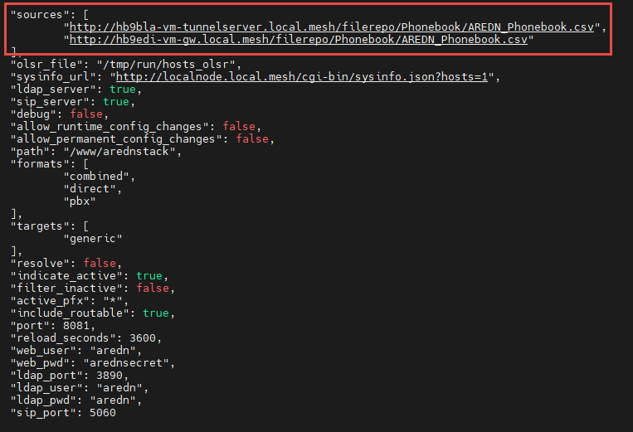
The second path is for backup.

